COS225 Assignment #2 Name ________________________
Due: Friday 2/9/18
Late: Friday 2/16/18
Readings: Chapter 14

Assignments should be submitted to Blackboard by the due Note: Read directions on Assg #1 regarding submission requirements. They will no longer be repeated.

Create a Word or RTF or PDF document (no other formats please) named A2YourName (use your own name) with answers to Part I questions and the screen shots of program output.

Part I. (20 pts) Enter answers into your document; please do not include this document.

1. Which statement is false about JavaFX programs?

a. Every program extends the javafx.application.Application class.
b. Every program overrides the start method found in the javafx.application.Application class.
c. If a public static void main method is needed, it calls the Application.launch method.
d. Every program has a primary Scene object upon which are placed one or more Stage objects.

2. Note the letter of true statements. There may be any number of correct answers.

a. Scene class derives from Node. b. Node class derives from Stage.
c. Circle class derives from Shape. d. Pane class derives from Node.

3. Note the letter of true statements. There may be any number of correct answers.

a. A node can be added to a pane. b. A scene can be added to a pane.
c. A scene can be added to a stage. d. A button can be added to a pane.

4. To add a circle object to a pane, use _____.

a. pane.add(circle); b. pane.addAll(circle);
c. pane.getChildren( ).add(circle); d. pane.getChildren ().addAll(circle);

5. A _______________ is used to place nodes one on top of the other in the center of the scene.

a. Pane b. BorderPane
c. StackPane d. ImageView

6. Which statement is false about coordinates used with a Pane object?

a. Coordinates of the upper left corner of the pane are (0,0).
b. Moving down in a pane decreases the y-coordinate.
c. Unlike the StackPane class, the Pane class offers positioning of nodes.
d. A circle with center coordinates (100,100) placed in a pane displays 100 pixels down and right from
the upper left corner of the pane.

7. The color described by: new Color(0.18, 0.9, 0.79, 1); is best described as:

a. olive green b. turquoise
c. orange-red d. dark purple

8. A program displays a circle. When the window is resized by the user, the circle remains centered in the window. This is known as _______________.

a. animation b. property binding
c. setting styles d. using an ImageView

9. Fill in the code as described by comment.

public class FontDemo extends Application {
@Override
public void start(Stage primaryStage) {
StackPane pane = new StackPane( );
Circle circle = new Circle( );
circle.setRadius(50);
circle.setStroke(Color.BLUE);
circle.setFill(Color.RED));
Label label = new Label("HI");

// add Circle and then Label nodes to pane
__________________________________

Scene scene = new Scene(pane, 200, 200);
primaryStage.setTitle("ShowCircle");
primaryStage.setScene(scene);
primaryStage.show( );
}
}

10. Which statement best describes the program in Question #9?

a. A blue filled circle appears with the word HI directly in its center.
b. A red filled circle appears in the upper left corner of the window.
c. A circle appears with the word HI displaying to its right side.
d. A red filled circle containing word HI appears in the center of the window
Part II. (80 pts.) Write a program to solve the following problem. Use the code written for Assignment #1 and display the field of plots using JavaFX. Use an image of a field with a brown fence around it. Plots can be solid colored rectangles of different colors.
Set the dimensions to 200, plot dimensions to 20, and number of plots to 6. Under the field display your name and a list of each plot color in a rectangle of black border and correct color and upper left coordinate. Change the font name and font size from default values to some different font (not ones seen like Courier New or Times New Roman).

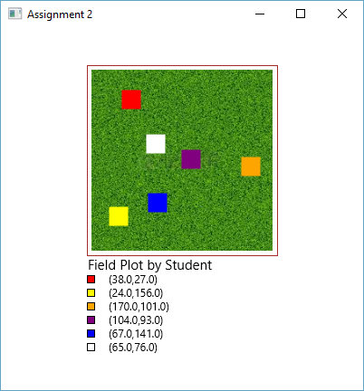

Paste two sample screenshots into a single Word or RTF or PDF document (no other formats accepted).
Click the Blackboard Assignment #2 link and attach your document and .jar file. The grader will run your program and critique the code.

Note: Assignments will be graded within one week. If you have questions or concerns about the grade, it is your responsibility to see the instructor within one week of the return date. No assignments will be revisited after this time period.

